To deploy a project to Kubernetes on Azure Cloud, you need to create a Kubernetes Services. First, open Azure, type in the search bar and select Kubernetes services.

Select Kubernetes cluster

Select Resource group

Cluster preset configuration: Dev/Test

Set a name for the Kubernetes cluster name

Select Region

Choose the appropriate AKS pricing tier

Finally click Next

Select Node size for Kubernetes , click on the current node to change

In the Node size section, select Choose a size

Choose the appropriate VM

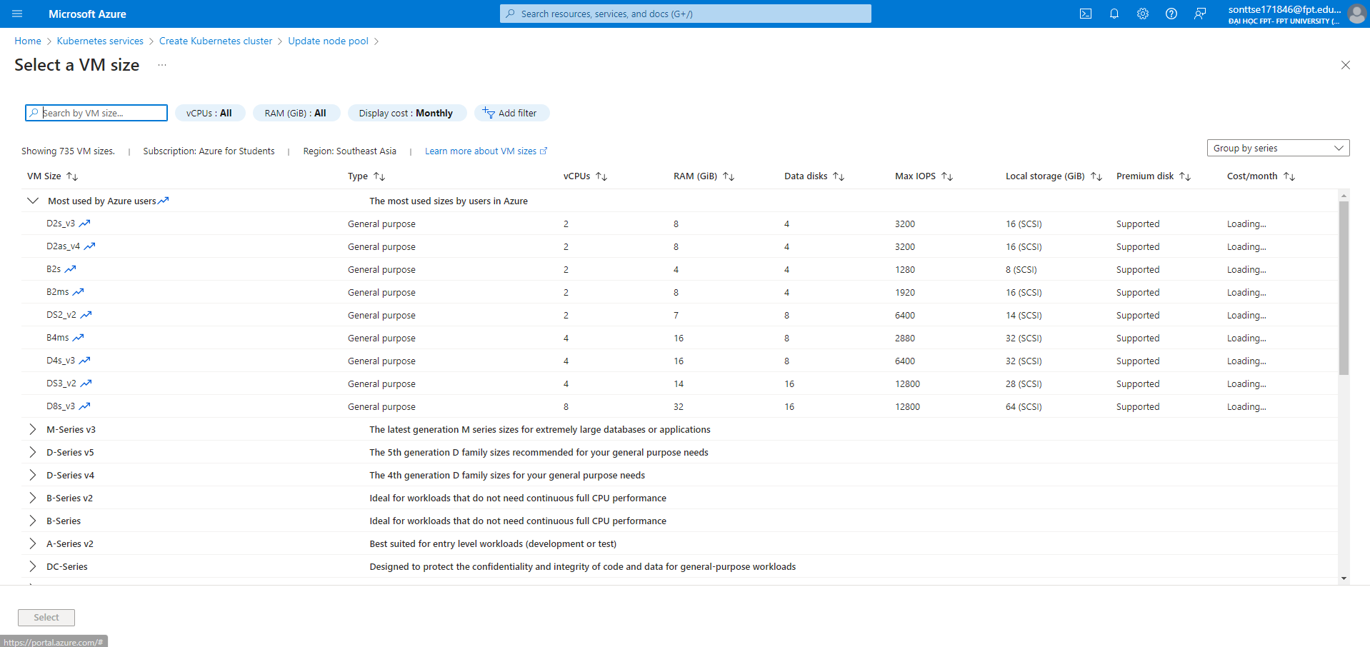

After selecting the VM, click Update

Click Next

next

In the Container registry section, select the container, and finally select Review + create

This is kubernetes after successful creation

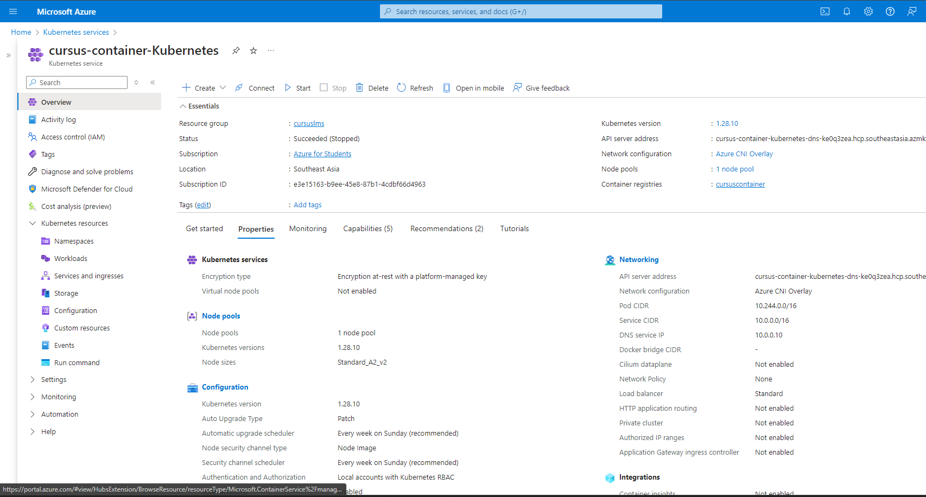

Next we will create a Dockerfile file to build and push the image from Docker to the Container Registry

Right click on the project API, select Add, Select Docker Support…, the Dockerfile will be created

Dockerfile after being created

In the root directory of the project, create a deployment.yaml file, this is the file used to configure service deployment

This is the sample file

Please correct the Image name and path in the Repository of the Container Registry on Azure

Next open terminal in Visual Studio and type the following commands:

az login

* az acr login --name <name container>



* az aks get-credentials --resource-group <Resource Group Name> --name <Kubernetes Name> --overwrite-existing



* docker build -t <image on Container Registry>

Image is created in images of Docker

* docker push <image on Container Registry>

kubectl apply -f deployment.yaml



If you want to delete Kubernetes Services

kubectl delete -f deployment.yaml



kubectl get pods

kubectl get services

Open a browser and enter External-IP and test the API

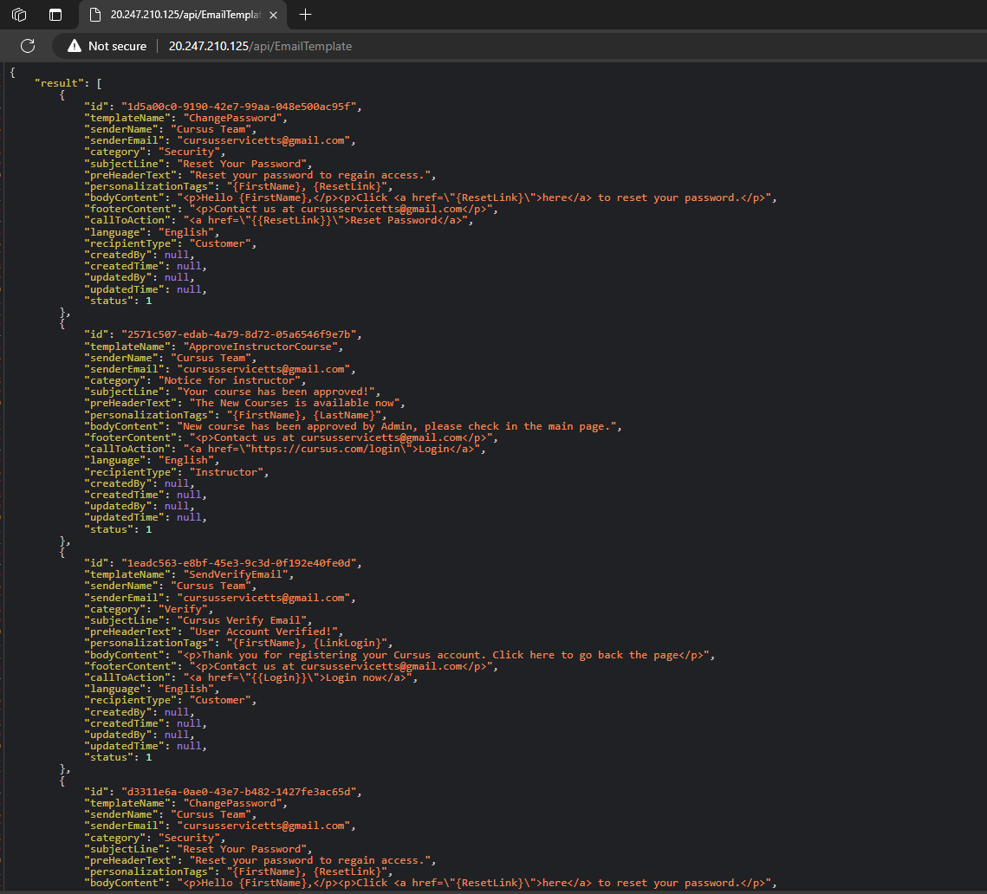

Retrieved data from API

Same with Frontend using React-Vite

Create a Dockerfile in the project root directory

# First, use a node image to build the application.

FROM node:18 AS build

# Set working directory

WORKDIR /app

COPY package*.json ./

# Install dependencies

RUN npm install

# Copy entire source code

COPY . .

# Building applications

RUN npm run build

# Now, use an nginx image to serve the application.

FROM nginx:alpine

# Copy build files from previous stage to nginx

COPY --from=build /app/dist /usr/share/nginx/html

# Expose port 80

EXPOSE 80

# Run nginx when container starts

CMD ["nginx", "-g", "daemon off;"]

Open terminal and run the following commands:

az login

az acr login --name <name container>

az aks get-credentials --resource-group <Resource Group Name> --name <Kubernetes Name> --overwrite-existing

docker build -t <image on Container Registry>

docker push <image on Container Registry>

kubectl apply -f deployment.yaml 

If you want to delete Kubernetes Services

kubectl delete -f deployment.yaml

kubectl get pods

kubectl get services

Enter External-IP to test Frontend on Kubernetes

Frontend project has been successfully deployed to Kubernetes

Deployment of both Backend and Frontend projects to Kubernetes was successful